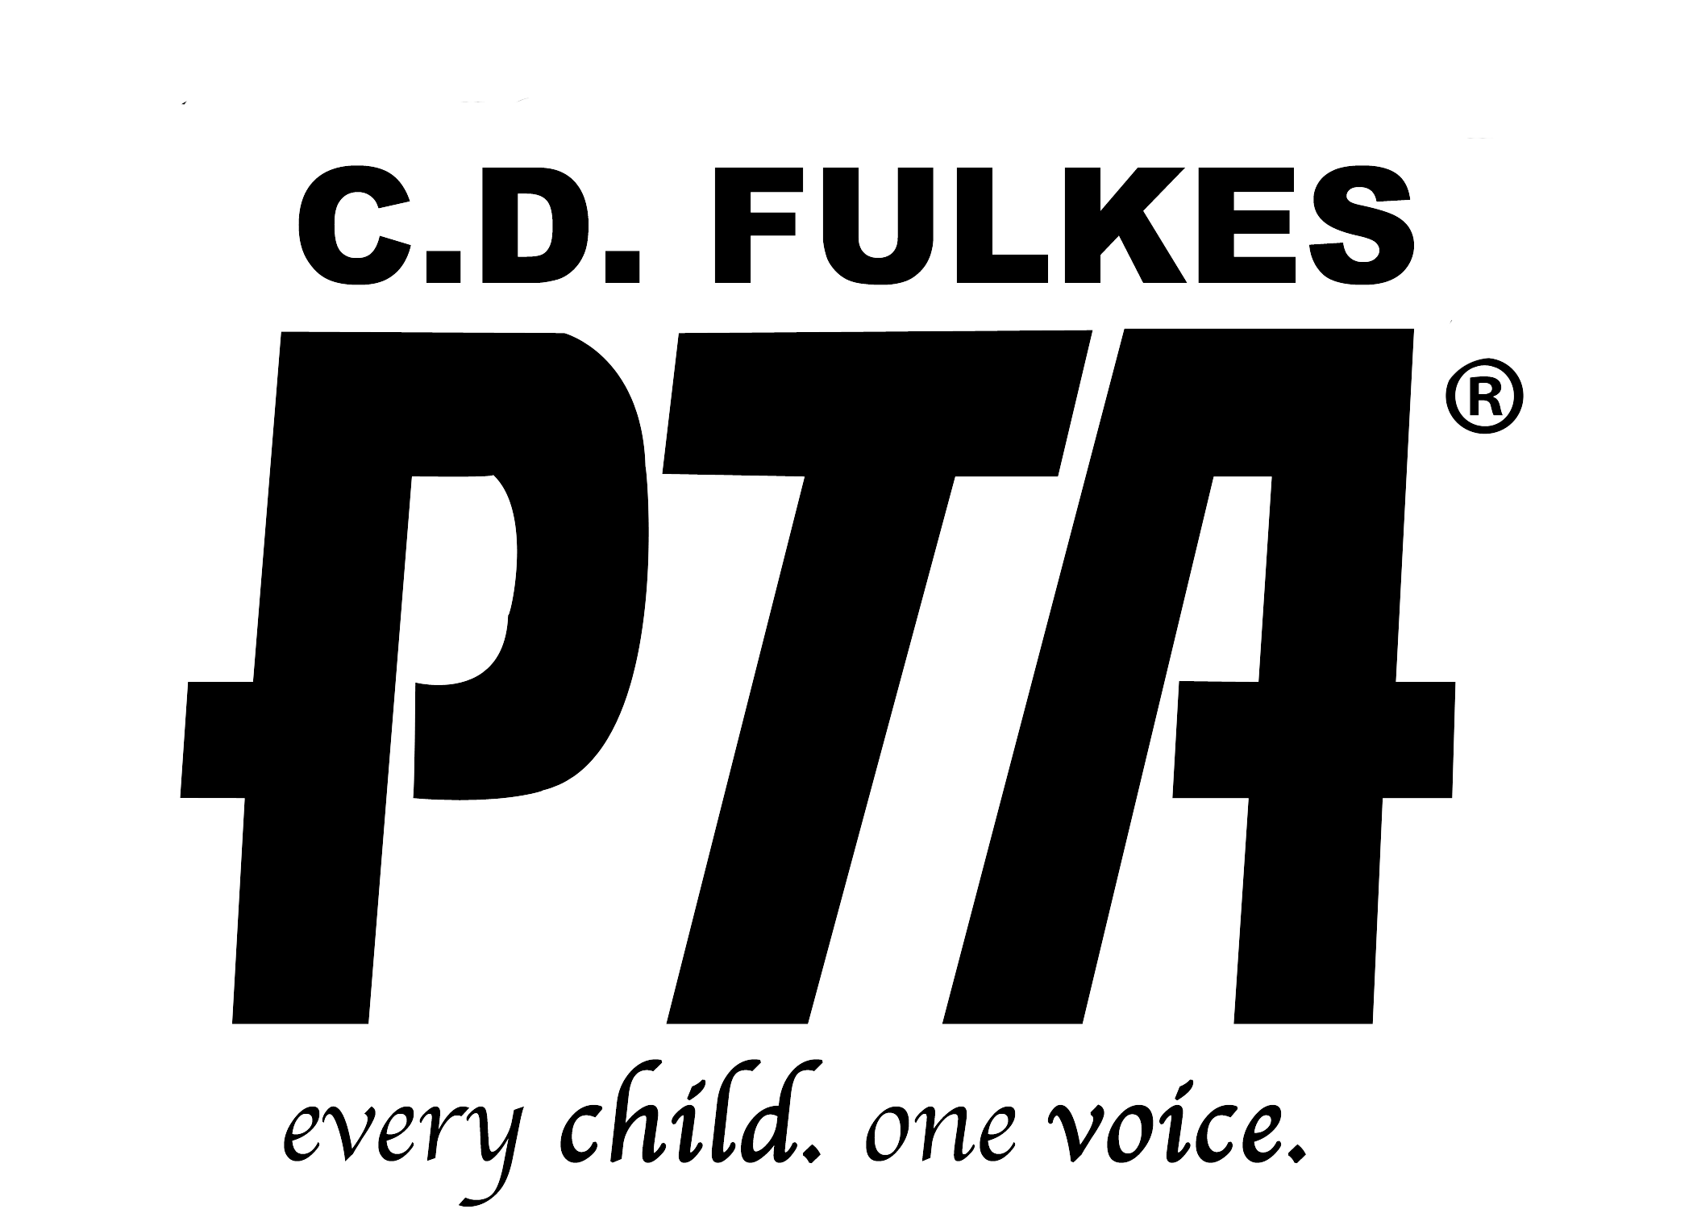
CD FULKES PTA MEMBERSHIP FORM

ANNUAL MEMBERSHIP FEE IS:
$ 8.00 FOR EACH ADULT

Join online with a credit card at www.joinpta.org
C.D. Fulkes Middle
($2.25 NATIONAL PTA DUES + $2.25 TEXAS PTA DUES + $ 3.50 C.D. Fulkes PTA DUES)
Make CHECKS out to: C.D. Fulkes M.S. PTA

Primary member name |  | CDF EMPLOYEE   YES  NO
Street address
City
State
Zip
Home Phone
Cell Phone
Email

Additional member name |  | CDF EMPLOYEE   YES  NO
Street address
City
State
Zip
Home Phone
Cell Phone
Email

Child’s Name (so that we can get you a PTA membership card)
Child’s Advisory teachers name (On their schedule) |  | Grade

☐ Yes, please email me about CD Fulkes VOLUNTEER needs
☐ Yes, contact me about a LEADERSHIP position on the PTA board or a PTA committee position
CDFPTAPRESIDENT@GMAIL.COM

FOR PTA BOARD MEMBER USE ONLY
T-shirt(s) sold Qty. ________ | ☐ Cash/Amount | ☐ Check #
Donation Amount | ☐ Cash/Amount | ☐ Check #
Membership(s) Amount | ☐ Cash/Amount | ☐ Check #
Total | Cash Amount: | Check Amount:
Board Member’s name that received funds
Date funds received

C.D. Fulkes Middle School  300 West Anderson Ave.  Round Rock  Texas  78664  Attention: PTA
WHAT WE DO

Bring together School, Community, Parents, and Students...
- Host the 6,7,8 grade fall homecoming dance in October
- Cohost the ‘Student Performs On Target’ awards five times a year in the library
- Purchase pastries, drinks, and yard/window signs for the five S.P.O.T. awards
- Host a "Coffee with the principal" right after the SPOT awards in the library from 8:20-9:00am
- Purchase treats for five Academic Awards for our outstanding A, A/B honor roll students. At the end of 2018 we changed it up and hosted a party with a snack, drink, and music in the lunchroom for all A, A/B students, at the end of each six week grading period
- Purchase trophies for Citizenship Integrity Achievement awards
- Provide an art program called PTA Reflections to any student that wishes to participate in it.
- Set up a healthy booth at the C.D. Fulkes C.A.T.C.H. night. (Coordinated approach to children's health)
- Offer a monthly wellness tip on Facebook
- ​Host a fall pre-holiday Luncheon for the CD Fulkes staff in November
- Donate 800 drinks & snacks for the Reindeer Run in December
- Host a spring Lunch or Breakfast for the CD Fulkes staff in May for national teacher appreciation
- Recruit volunteers for teachers and staff
- Create a basket for the Partners In Education fundraiser, to be auctioned off (this raises money for the Round Rock Independent School District)
- Donate to our school Library
- Host the 8th grade formal dance in May
- Donate clothing & volunteer monthly at the ‘RRISD clothes closet’ at Voigt Elementary. It is a service that provides gently used clothing, new socks, and new underwear to RRISD students in need.
- This past year our Healthy Lifestyles chair hosted Yoga classes and a 6-week step challenge for teachers and staff
- This past year we contributed to an educational movie showing called "screen agers" at the new Cedar Ridge HS auditorium in Jan. It was followed by a wonderful discussion
Thank you for your support!
CDF PTA website: http://ptacdfulkes.weebly.com
Like & Follow us on Facebook
Contact: cdfptapresident@gmail.com

If you would like to join, fill out the form on the back, include $, and return it to school. ➔

