JUST CAN’T HIDE THAT C.D. PRIDE!
P.T.A. Camiseta $10.00 $5.00
Camiseta gris/ impression de borgona
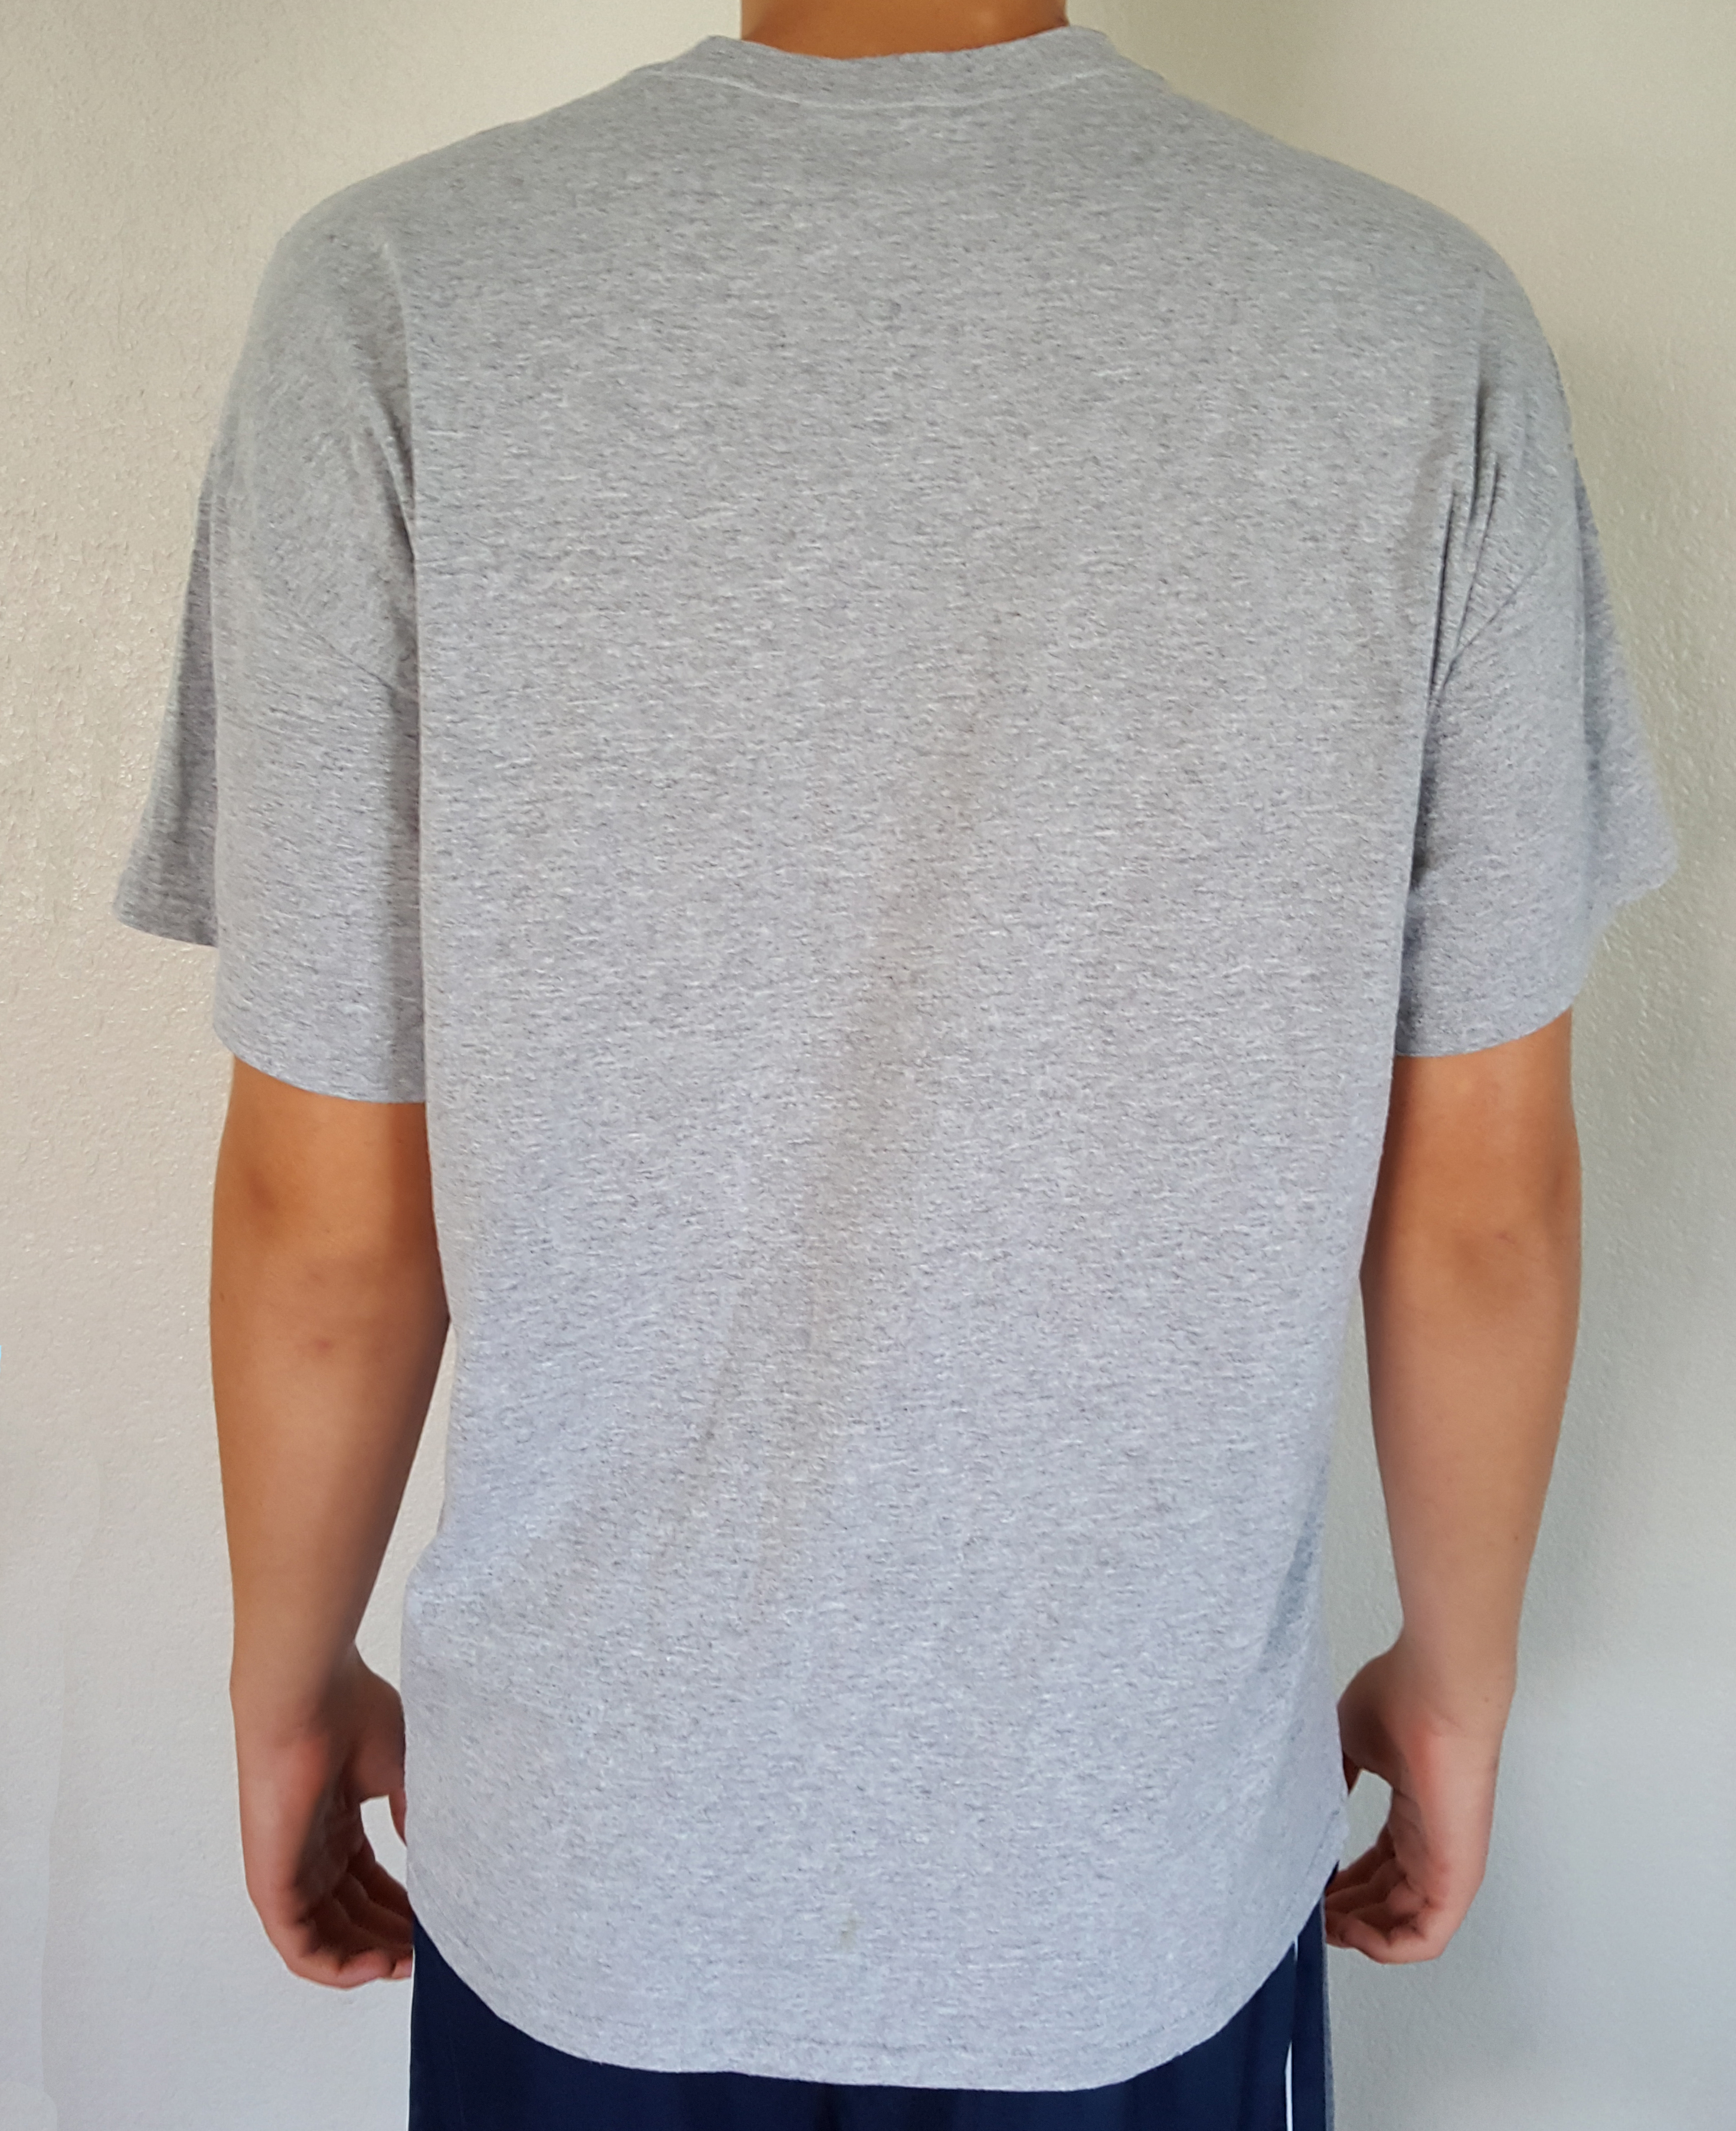
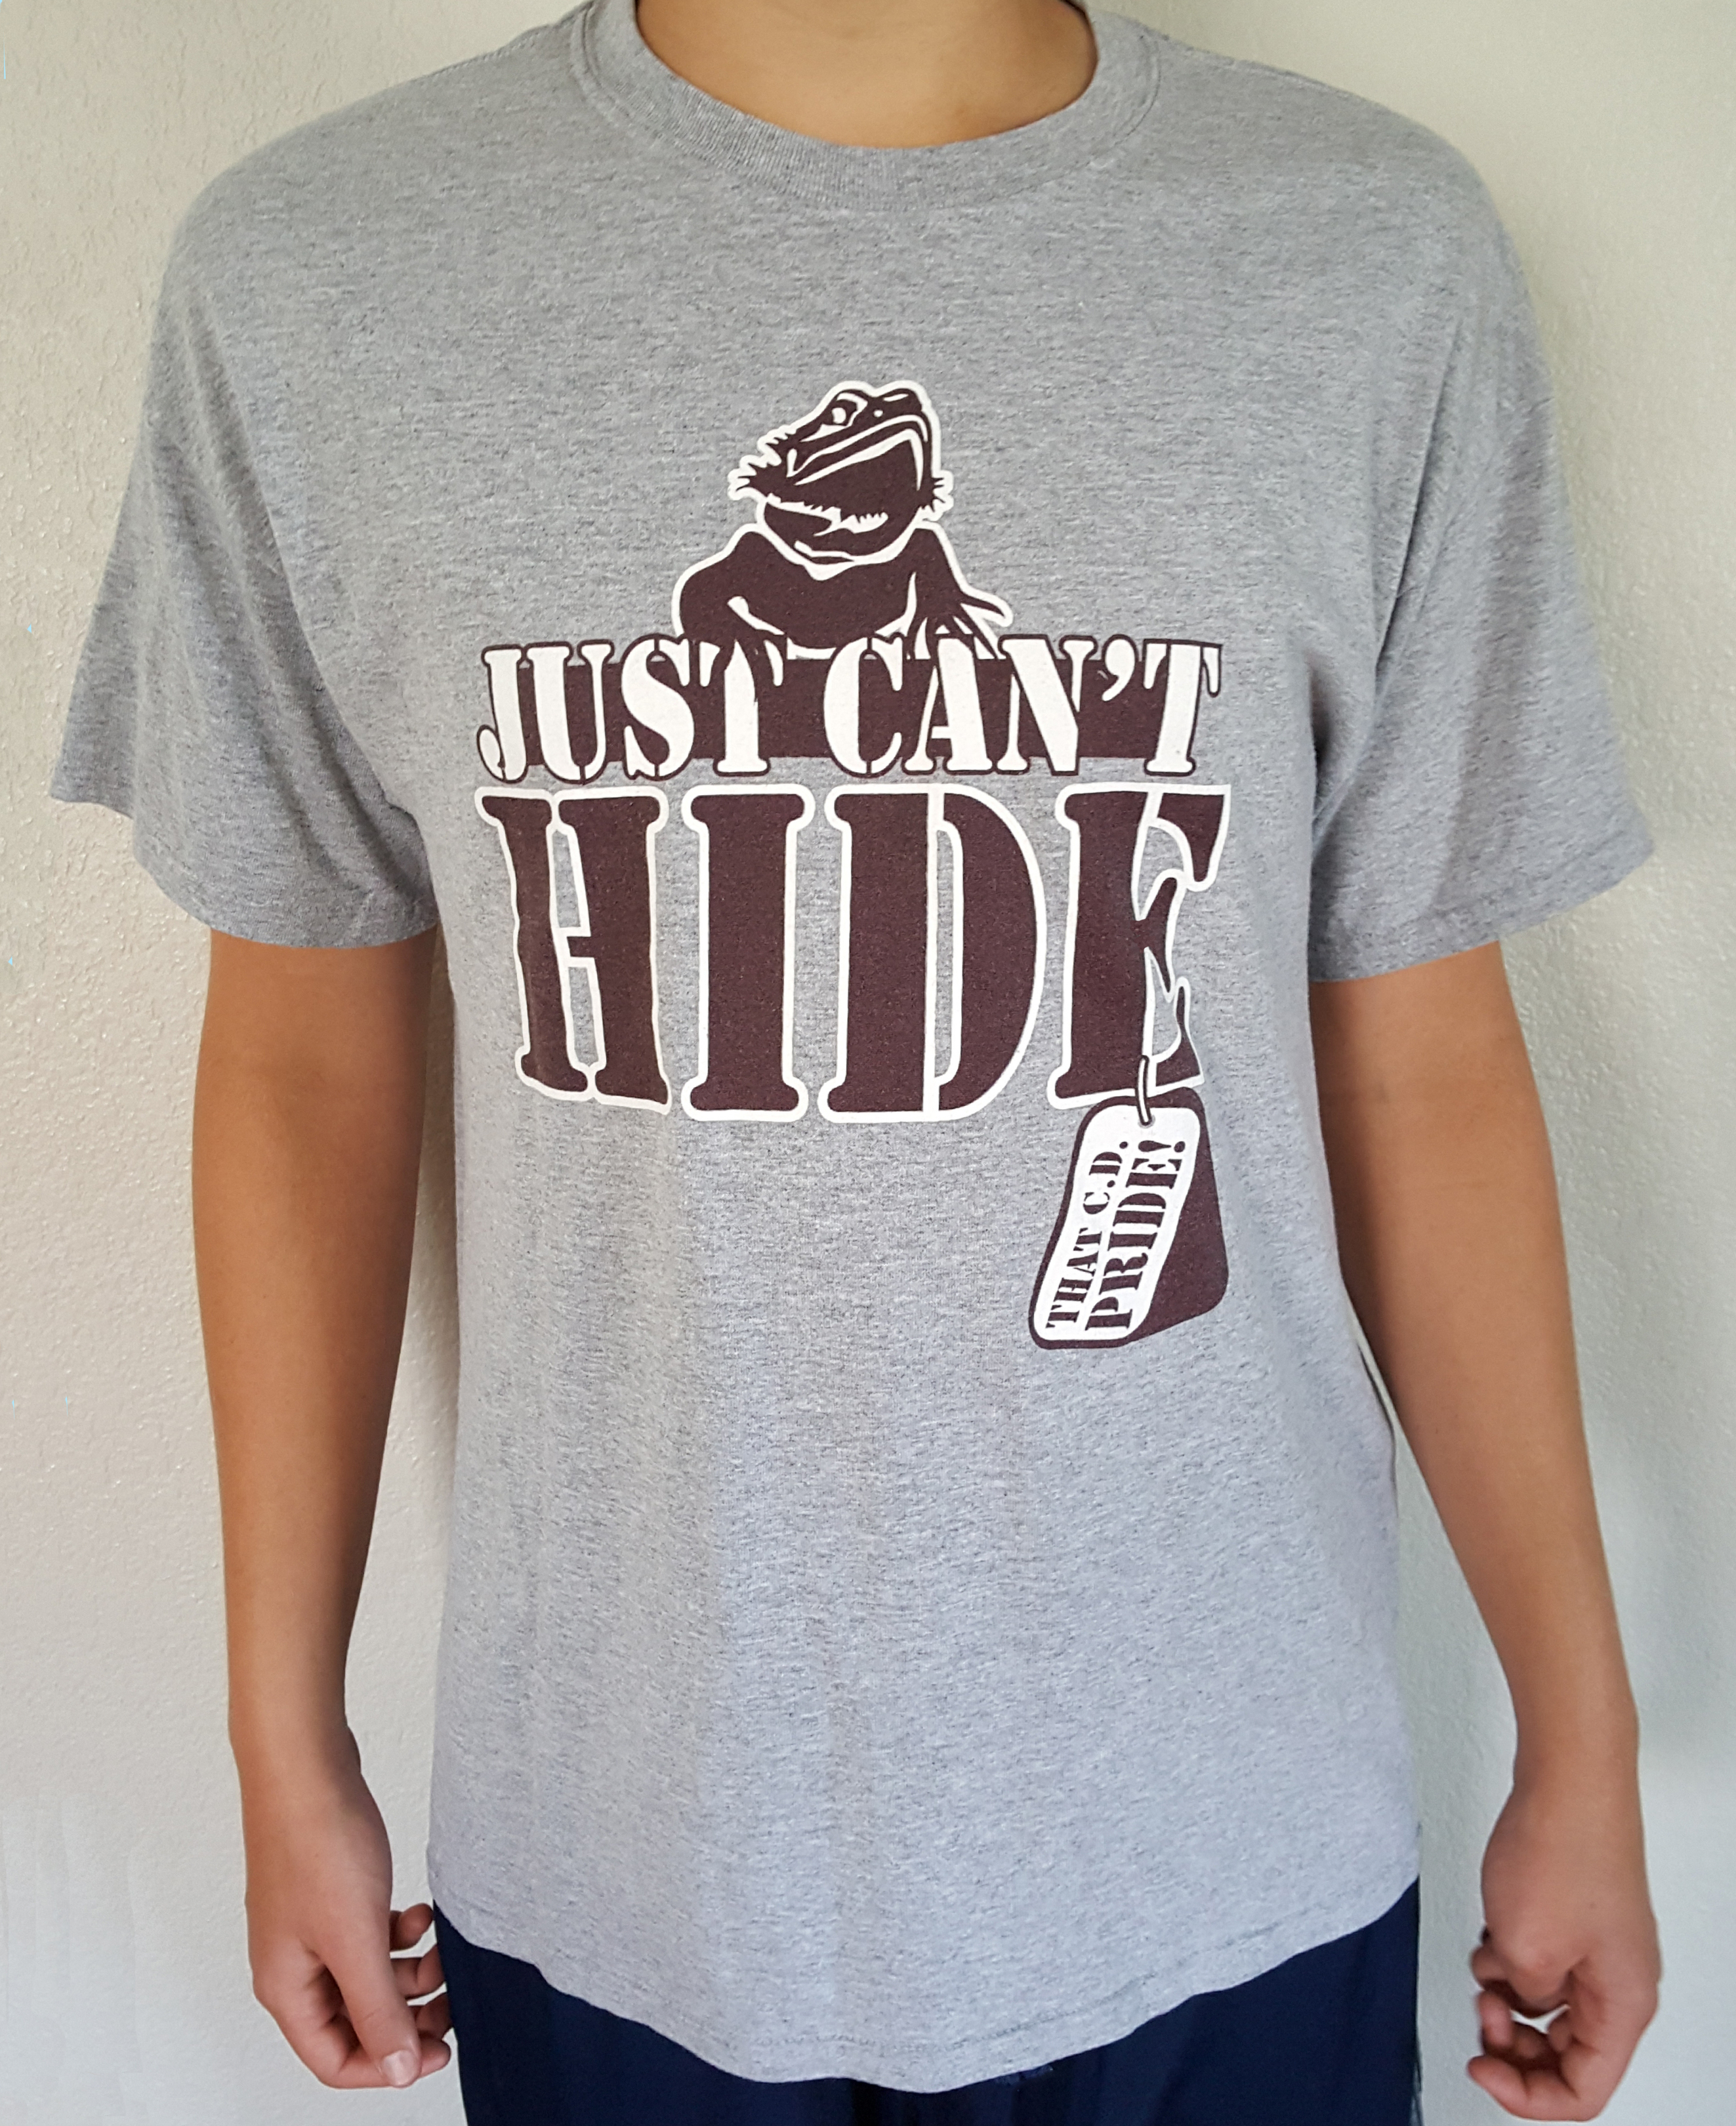

Si! Quiero ____cantidad. Camiseta(s) por $5.00 cada uno.

______cantidad. SMALL ______cantidad. MEDIUM ______cantidad. LARGE

______ cantidad. XL ______ cantidad. 2XL ______ cantidad. 3XL

Estoy encerrando un total de $ _________________

Por favor, dale la camiseta a mi hijo/a(nombre):______________________________________

En su asesoria (nombre de maestro/a) ___________________________________

Su numero de telefono __________________________________________

Haga los cheques hacia fuera a: C.D. Fulkes Middle School P.T.A
JUST CAN’T HIDE THAT C.D. PRIDE!
P.T.A. T-SHIRT $10.00 $5.00
Grey shirt / Burgundy print

Yes! I want _________Qty. T-shirt(s) for $5.00 each.

______Qty. SMALL ______Qty. MEDIUM ______Qty. LARGE ______Qty. XL

______Qty.2 XL ______Qty.3 XL

I am enclosing a total of $ _________________

Please give the t-shirt to my child (name): ________________________________________

In their advisory (advisory teachers name): ______________________________________

Your phone number: __________________________________________

MAKE CHECKS OUT TO: C.D. Fulkes Middle School P.T.A.

